ORCHID INTERNATIONAL COLLEGE
Tribhuvan University
Faculties of Computer Science

Bachelors of Science in Computer Science and Information
Technology
(BSc. CSIT)
Course: Numerical Method (CSC-207)
Semester: III
LAB = 6
A Lab Report On:
Solution of Partial Differential Equations
Submitted to:
Ganesh Thapa
Faculty, Department of Computer Science
Submitted by:
Name: Aaryan Kushawaha
Roll No: 28900/078

LAB = 5
TITLE: Solution of Ordinary Differential Equations

OBJECTIVES :
- To study Solution of Ordinary Differential Equations methods used to find the value using provided reference data.

THEORY:
- The theory of solving Ordinary Differential Equations (ODEs) encompasses various methods and techniques to find solutions for equations that involve derivatives of a single variable. ODEs are fundamental in describing a wide range of phenomena in science and engineering, from simple harmonic motion to complex dynamics in physics, biology, and more.

1. Euler's Method:

Concept:
- The concept of derivatives using the forward difference method is a numerical approach to estimate the derivative of a function at a particular point by calculating the slope of the secant line passing through that point and a neighboring point slightly ahead of it. This method is based on the definition of the derivative, which is the rate of change of a function with respect to its independent variable.
- The forward difference approximation of the derivative is defined as:

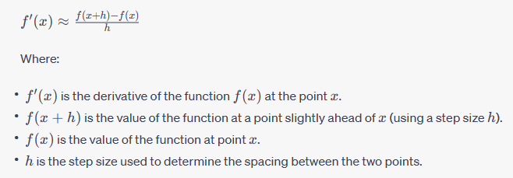

Formula:
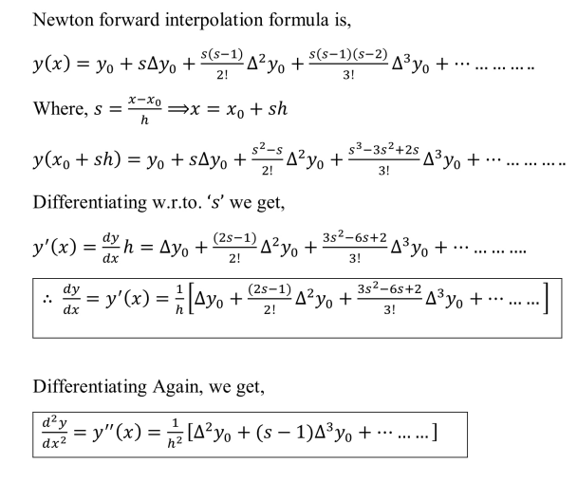

2. RK - 2 Method:
Let, function f(x) pow(sin(x),0.5)
Concept:

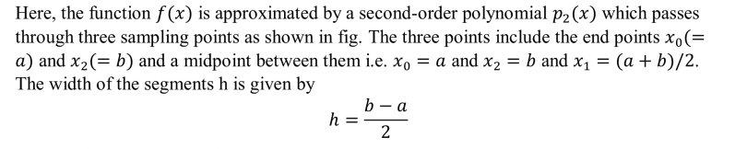
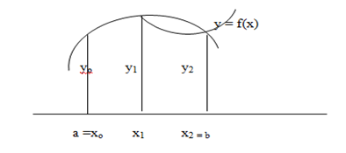
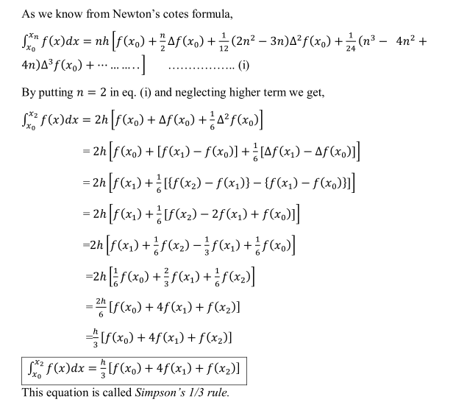

3. RK - 4 Method :

Concept:
- Simpson's 3/8 rule, also known as Simpson's Three-Eighths Rule, is a numerical integration
technique used to approximate the definite integral of a function over a specified interval. It's an extension of the simpler Simpson's 1/3 rule and provides a way to estimate integrals when the number of subintervals is not divisible by 2 (i.e., when the number of intervals is not even). This rule offers higher accuracy than the 1/3 rule for a wider range of functions.
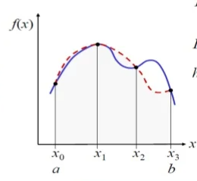
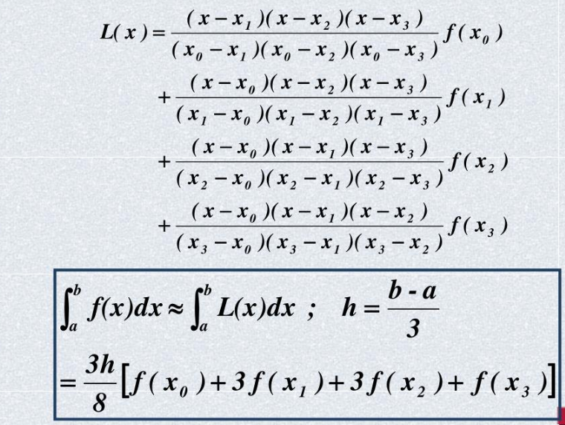

4. Shooting Method:

Concept:
- Let , f(x) be the function X0 = a & X1 = b.

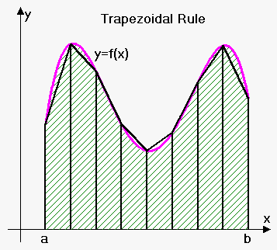

h = X1– X0
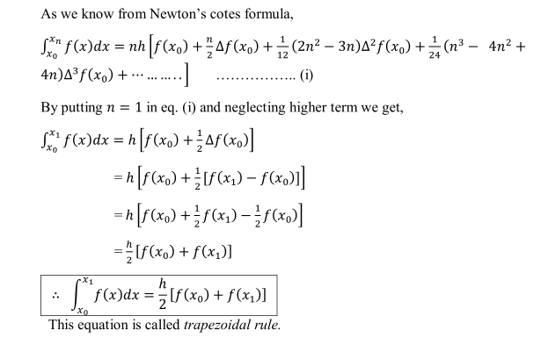

PRACTICAL IMPLEMENTATION

TASK 1: Euler's Method
ALGORITHM :
1. Start
2. Read number of data (n)
3. Read data points for x and y:
For i = 0 to n-1
Read X_{i} and Y_{i,0}
Next i
4. Read calculation point where derivative is required (xp)
5. Set variable flag to 0
6. Check whether given point is valid data point or not.
If it is valid point then get its position at variable index
For i = 0 to n-1
If |xp - X_{i}| < 0.0001
index = i
flag = 1
break from loop
End If

Next i
7. If given calculation point (xp) is not in
x-data then terminate the process.
If flag = 0
Print "Invalid Calculation Point"
Exit
End If
8. Generate forward difference table
For i = 1 to n-1
For j = 0 to n-1-i
Y_{j,i} = Y_{j+1,i-1} - Y_{j,i-1}
Next j
Next i
9. Calculate finite difference: h = X₁ - X₀
10. Set sum = 0 and sign = 1
11. Calculate sum of different terms in formula
to find derivatives using Newton's forward
difference formula:
For i = 1 to n-1-index
term = (Y_{index, i})^{i} / i
sum = sum + sign * term
sign = -sign
Next i
12. Divide sum by finite difference (h) to get result
first_derivative = sum/h
13. Display value of first_derivative
14. Stop

OUTPUT:
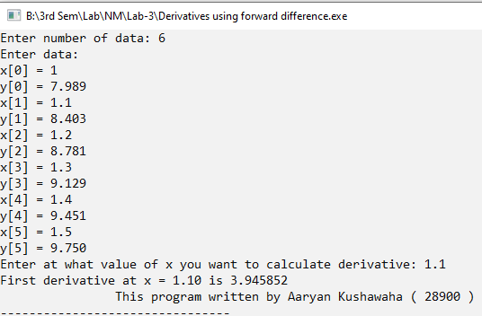

TASK 2: RK - 2 Method
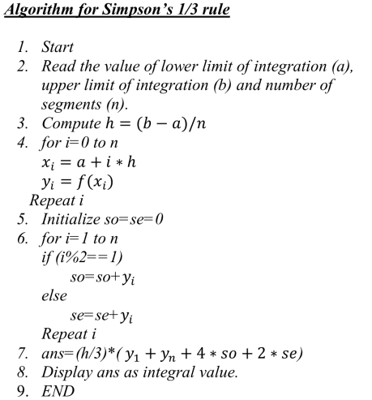

OUTPUT:
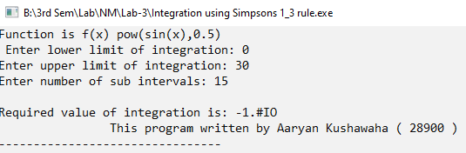

TASK 3: RK - 4 Method
ALGORITHM:

1. Start

2. Define function f(x)

3. Read lower limit of integration, upper limit of integration and number of sub interval

4. Calcultae: step size = (upper limit - lower limit)/number of sub interval

5. Set: integration value = f(lower limit) + f(upper limit)

6. Set: i = 1

7. If i > number of sub interval then goto

8. Calculate: k = lower limit + i * h

9. If i mod 3 =0 then
Integration value = Integration Value + 2* f(k)
Otherwise
Integration Value = Integration Value + 3 * f(k)
End If
10. Increment i by 1 i.e. i = i+1 and go to step 7

11. Calculate: Integration value = Integration value * step size*3/8

12. Display Integration value as required answer

13. Stop

OUTPUT:
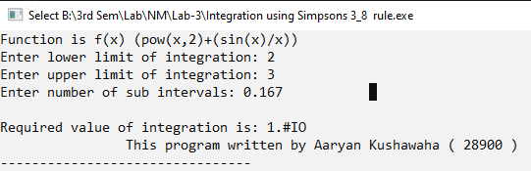

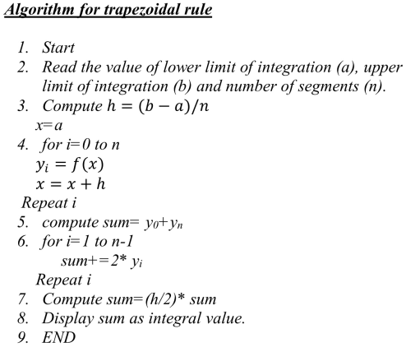
TASK 4 : Shooting Method

OUTPUT:

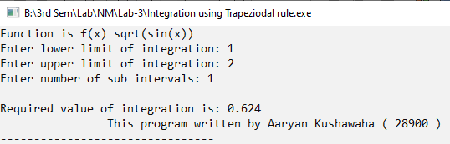

CONCLUSION:
Program to implement solving the Derivative using forward difference , integration Simpson 1/3 , 3/8 & Integration using trapeziodal Rule using C Language , were written using High level language & Respective output of each program . Therefore , all results were satisfied by the program.

